Meeting 1
Date: 8/25/25
Time: 11:00am-12:00pm CDT
Attendees: Juliette Reeder, Jack Hicks, Marshall Sowell, Carl Hagen, Dr. Chuck Bunting

Context:
HF communications antennas sit on the surface of naval vessels. These vessels also have missiles and planes and other electronic systems sitting on the surface of the vessel, exposed to a constant EM field generated by the antenna. Testing is conducted to ensure these electronic systems are not disrupted by the EM field at Dahlgren before deployment.
Currently, these systems are all tested using two systems: one is a vertical whip antenna setup with an integrated tuner and the other is a telescoping antenna (used more rarely). For larger missiles or equipment, this means involving a crane to hold the device vertically. Some missiles are large enough to make the crane system not feasible, introducing the need for a horizontal HF antenna system.$\frac{468}{f}$

Broadband High Power HF Antenna Design Constraints:
- Need to hit frequencies listed
  - These are not legal for amateur radio operators
    - Surrogate frequencies for higher end of spectrum
    - VNA simulation for lower end of spectrum (requested EM probe for 80m testing)
    - Can create a dummy load with LCR circuit to test in anechoic chamber
  - Goal is to hit 10 frequencies, but 5 is the bare minimum
    - Be communicative about what is possible
    - Range can be adjusted to 13-26 MHz if needed
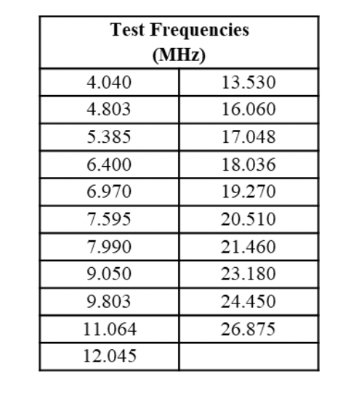
- High power is not needed (or legal) for this design
  - Indicate how antenna can be scaled to 10kW / 200 V/m
  - Look into high power balun / tuner, or indicate scaling for balun/tuner
- Size is not a real constraint, but remain reasonable
  - Antenna is stored outside; consider protecting from weather damage
- 50Ω impedance matching

People to reach out to:
- KC9DCO - Tim Sickbert (may have loaner transmitter)
- Dr. O’Hara (may have loaner transmitter)
- Logan Frailey (regarding Dr. Bunting’s schedule)

Action items:
- Look in to whip antennas
- Look in to other antenna types; identify two to do an in-depth comparison with the whip antenna
  - Random-Wire antenna (suggested by Dr. Bunting; needs tuner and balun)
    - Links from Dr. Bunting:
    - https://webclass.org/k5ijb/antennas/End-fed-multiband-antenna-BalunDesigns.htm
    - https://www.hamuniverse.com/randomwireantennalengths.html
    - https://www.kb6nu.com/playing-end-fed-wire-antennas-91-ununs/
    - https://udel.edu/~mm/ham/randomWire/
  - Log periodic (will likely be very large)
  - Loop antenna (very high current - likely bad transmitter)
- Prepare for PDR
- Plan on monthly meetings with Dahlgren
- Plan on weekly emails with Dahlgren
- Set up a weekly meeting with Dr. Bunting

